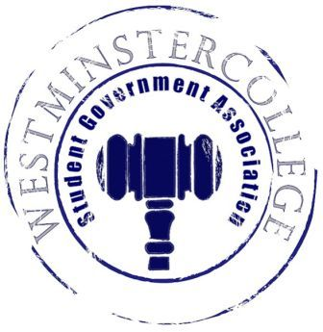
Student Government Association
May 4, 2016
Meeting Minutes

- Prayer by Michael Angiolelli
- Roll Call and Announcements
All senators are here and accounted for except Kyle Daly, Paul Carswell, John Arcuri, Matt Slagle, Denver Baker, Alix Rea, Rachel Trauner, Megan Douds, Nataleigh Kerr, Taylor Chock-Wong
- Approval of Minutes
- Motion to approve last week’s minutes by Nolan Randall, seconded by Alex Rollo
- Executive Officers Report
President – Cory Hughes
- Wireless Woes
  - Issue with Cisco authentication
  - LIS has been working nonstop to rectify the issue
  - Will be followed by hardware/software updates to ensure this doesn’t happen again
- Enjoy your summers, and look forward to seeing everybody in the fall.
Vice President – Channing Pifer
- Have a good summer!
Secretary – Regino Flores
- 32 Senators in Attendance
Treasurer – David Jamieson
- $17.18 – Donuts for VolleyRock
- $12.95 – Don’t Categorize, Individualize Supplies (Diversity)
- $94.80 – Finals Week Treats (Academics)
- Good luck seniors, and good luck on finals.
Open Forum
Committee Meetings
Finance – Carl Carpenter
- Audits & Allocations Presentation
Academics – Anna Daniels
- Enrollment Committee discussed ways to improve enrollment
- SLAC met
  - Approved Super Smash Brothers Club
  - Looking for a way to monitor status of SLAC-approved organizations
- Instructional Resources Committee
  - Looking for a more streamlined alternative to my.westminster
- Finals Week in the Library
  - Snacks provided in limited amounts each day – first come, first serve
Diversity – Jordan Sherman
- Speaker
  - Elizabeth Azcevado, a spoken word poet, will be coming to campus in the Fall
  - Joint event between Diversity, CPC, and BSU
- Don’t Categorize, Individualize
  - Cookies tomorrow (Thursday May 5th)
  - Write post-it note secrets!
Special Events – Heaven Brown
- Petting Zoo at SGA Day
  - Unlimited feed
  - Camel
  - Rain may interfere with camel attendance
Service- Chloe Knappenberger
- Organization of the Month
  - Congratulations to Alpha Gamma Delta!
- Finals Fairy
- End of Year Flex Donations
  - See a service committee member at the TUB table
Student Concerns – Chris Israel
- No Report
Public Relations – Amelia Hartzell
- SGA Day
  - Free pizza, apple castle donuts, and golf cart rides
- Golf Cart Presentation
- Old Business
- New Business
  - Motion by Michael McClain to approve Audits & Allocations budget
    - Passed in Senate by a unanimous vote.
- Open Floor
  - Phi Mu selling pancakes (regular and chocolate chip) on Saturday for $3
  - Wind ensemble concert this Friday at 7
  - CPC Freebie Friday – Free gray Westminster t-shirts in Berlin Lounge
    - If you can’t make it, send Sierra Downing an e-mail (50 shirts will be reserved)
  - Zetas are having a spaghetti dinner on Friday. Find a sister to buy a ticket
  - Alpha Sigma Phi Relay for Life this Saturday from 10 A.M. to 10 P.M.
  - Theta Chi G.I. Benefit concert in Berlin Lounge from 1-3 on Saturday, tickets cost $3
- Adjournment
- Motion to adjourn by Nolan Randall, seconded by Jessica Garcia-Ramirez

