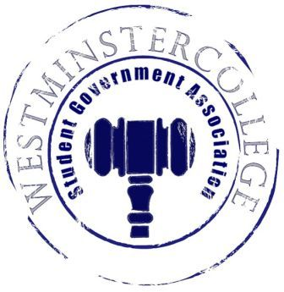
Student Government Association
December 7, 2016
Meeting Minutes

- Prayer by Michael Angiolelli
- Roll Call and Announcements
All senators are here and accounted for except Matt Slagle and Denver Baker.
- Approval of Minutes
- Motion to approve last week’s minutes by John Arcuri, seconded by Devin Furness.
- Executive Officers Report
President – Cory Hughes
- Slate Election
  - Applications Due Friday
Vice President – Channing Pifer
- No Report
Secretary – Regino Flores
- Senator Attendance
  - 42 Senators in attendance – RECORD!
- Birthdays
  - Happy Birthday AnDan!!
Treasurer – David Jamieson
- $25 Student Organization of the Month
Open Forum
Committee Meetings
Finance – Carl Carpenter
- No Report
Academics – Anna Daniels
- Committee Reports
  - URAC Committee
    - How to improve URAC overall
    - Main speaker – FBI analyst from Africa, WC alum
    - Change the schedule a little so everybody can attend more events
    - Improve PR for URAC
    - Students encouraged to take pictures and use hashtag
    - Potential “Pilot Summers” Program – paid a stipend to stay over the summer and do research with professor
  - Curriculum Committee
    - Changed current history capstone into two 2-credit courses instead of one 4-credit
    - Approved 400-level history course “Teaching Social Studies in Secondary Schools”
Diversity – Jordan Sherman
- International Festival
  - Tomorrow December 8 from 5-7 in the Berlin Lounge
  - Explores different holidays through this season
Special Events – Heaven Brown
- No Report

Service- Chloe Knappenberger
- Flowers & Donuts
- Thank-you Breakfast
  - Bagels, donuts, coffee in Witherspoon next Wednesday
- Finals Elf
Student Concerns – Chris Israel
- Light Post
  - Removal of the tree did not help
  - Will install new light post at Russell
- Chunk missing from ramp down to McClure Run
- Ordering Breakfast items up until 10:30
- Sandwich toaster in the TUB instead of panini grill
- Food prices in general
Public Relations – Amelia Hartzell
- Christmas Party
  - Over 100 people showed up!!
  - Thank you to Phi Mu for the cookies
- Old Business
- New Business
- Open Floor
  - PRSA selling puppy chow in the TUB
  - This Saturday is the Oboe/String recital at 6 P.M. at 2 Rivers Coffee House in New Castle
  - CPC putting on event – Noah Hoam this Friday at 7 in Berlin Lounge
  - Phi Mu is selling pancakes for $3 to deliver to your rooms – talk to a sister
  - Friday at 4 is the CJS and Political history Capstone presentation
  - Sig Eps is selling chicken patties Saturday evening – check your e-mail
  - Merry Christmas
- Adjournment
- Motion to adjourn by Jessica Garcia-Ramirez, seconded by Emily Eyler

