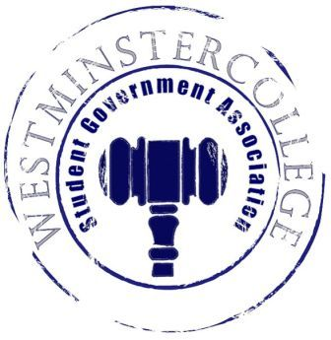
Student Government Association
November 7th, 2018
Meeting Minutes

- Prayer by Brandon Williams
- Roll Call and Announcements
All senators are here and accounted for except Emily Wright, Marissa Decker, Cassidy Nielsen Gabrielle Weaver, and Shaemour Young.
- Approval of Minutes
- Motion to approve last week’s minutes by Noah Pollio, seconded by Olivia Jacobson.
- Executive Officers Report
President – Sarah Conn
- No Report
Vice President – Keely Flynn
- No Report
Secretary – Bill Madeja
- 31 Senators in Attendance Tonight
Treasurer – Matt McDonald
- Expenses for the week:
  - Student Organization Cook-Off Reimbursement - $83.94
  - Diversity Dodgeball Shirts - $363
Open Forum
Committee Meetings
Finance – Kyle Kovach
- Discussion of emergency vote for Model UN funding for Chicago Trip
  - Funding was approved for $1,287.13
Academics – David Peffer
- SEC met for organizational review, all the revisions have passed.
- Enrollment Management Council met and discussed that early acceptance is on par with last year’s early enrollment.
- URAC Planning Committee met last week, Summer Research Info session November 29th at 8 p.m.
  - URAC Planning Committee discussed promoting ideas for URAC Day in the Spring of 2019
Diversity – Celine Hildack
- Discussion of Diversity Dodgeball sign-ups
- ALLIES event November 13th at 6:30 in Maple Room
- Civil Dialogue November 16th at 4 p.m. in the Lakeview/Witherspoon Room
Special Events – Patricia Loughney
- Discussion of previously cancelled Pirates game
  - Possible New dates for Make-up Game
    - April 5th
    - May 3rd
- Discussion of Watch Party for the Men’s Soccer Team for their NCAA Playoff Appearance
  - Details to come
Service – Mackenzie Basalla
- Discussion of upcoming Poetry Slam in Berlin Lounge, Winner of The Poetry Slam gets $50 gift card of their choice!
  - This Friday the 9th from 8-9 p.m.
Student Concerns – Dom Boston
- Discussion about FAC meeting today about future projects for Duff and general results of the Sodexo Survey
Public Relations – Kendall Graham
- SGA Survey will be administered during lunch hours in the TUB
  - Seeking feedback from students about what they think SGA does, how impactful they are and so on.
- Old Business
- New Business
  - Motion by Andrius Burnelis to discuss when to plan the Pirates Spring semester game, seconded by Brandon Williams.
    - Options are April 5th and May 3rd
  - Motion by Andrius Burnelis to vote on Pirates game event, seconded by Brandon Williams
    - Game will be held on May 3^{rd.}
- Open Floor
  - CPC DIY Decorate your own Coffee Mug in Berlin Lounge at 7 p.m. tomorrow
  - CPC event to go see Bohemian Rhapsody in theaters on Monday, November 12th
    - Sign-ups are on Friday, November 9th
  - Diversity Dodgeball Sunday, November 11th 3:30 – 6:30 p.m.
- Adjournment
- Motion to adjourn by Mason Flanigan, seconded by Annalisa Echevarria.

