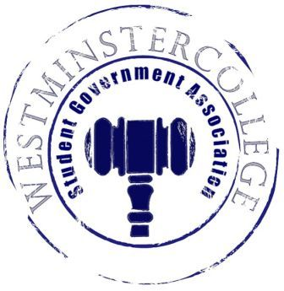
Student Government Association
May 2nd, 2018
Meeting Minutes

- Prayer by Brandon Williams
- Roll Call and Announcements
All senators are here and accounted for.
- Approval of Minutes
- Motion to approve last week’s minutes by Brandon Williams, seconded by Taylor Chock-Wong.
- Executive Officers Report
President – Sarah Conn
- Board of Trustees Report
- Have a great summer!
Vice President – Keely Flynn
- Thanks for helping at VolleyRock!
Secretary – Sam Stewart
- 32 Senators in attendance
- Happy birthday to First Year Senator Andrius Burnelis!
- Have a great summer!
Treasurer – Matt McDonald
- Proposed 2018-2019 SGA Budget
- Expenses
  - VolleyRock:
    - Prizes for Winners- $1,200
    - Supplies- $27.98
    - Prizes- $800
  - SGA Day:
    - Prizes- $1,255
  - Academics:
    - Finals Week Treats- $80.68
Open Forum
Committee Meetings
Finance – Kyle Kovach
- Potential Allocations Policy Change
  - Whether Student Organizations can buy T-shirts as promotional advertisement for their club
Academics – David Peffer
- McGill Finals Week
  - Stress relievers include: massage chairs, board games, bubble wrap, Mario Kart, snacks (fruit, granola bars, and chips) and stress balls
Diversity – Celine Hildack
- Civil Dialogue went well
- Have a great summer!
Special Events – Patricia Loughney
- SGA Day is Friday, May 4th
  - Find the Cash Cart to win prizes
Service – Mackenzie Basalla
- Susan Flynn Plaque Dedication on Saturday, May 5th at 1:45p.m.
- Clothing Swap is tomorrow, May 3rd
  - Have stuff in by 3:00p.m.
  - Will be held in Berlin 5:00-10:00p.m.
Student Concerns – Dom Boston
- Email Dom with concerns over the summer!
Public Relations – Kendall Graham
- Have a good summer!
- Old Business
- New Business
  - Motion by Brandon Williams to policy change to organization allocations, seconded by Andrius Burnelis.
  - Motion by Dylan John to discuss the proposed 2018-2019 SGA Budget for next year seconded by Taylor Chock-Wong
  - Motion by Brandon Williams to vote on the proposed 2018-2019 SGA Budget seconded by Adam Himmelman
    - The 2018-2019 Budget passed
- Open Floor
  - Phi Mu pancakes will be delivered on Saturday, May 5th in the morning
    - They are $3 from a sister
  - Zeta Tau Alpha will be holding a fundraiser at Buffalo Wild Wings tomorrow, Thursday May 3rd
    - Tell your server that you’re with ZTA and 10% of your check will go to breast cancer research
  - Softball team will be at PACs Friday, May 4th at 1:00p.m. at Thomas More
  - CPC will be bringing an acapella group Backtrack Friday, May 4th at 8:00p.m in Berlin Lounge.
    - Sweet Trebles will be opening
  - Band concert Friday, May 4th at 7:30p.m in Orr.
  - BSU will be showing 42 on Friday, May 4th at 5:30p.m.
  - The Wespy awards will be given out Sunday, May 6th at 3:00p.m in Orr.
- Adjournment
- Motion to adjourn by Teddy Constantine, seconded by Taylor Chock-Wong.

