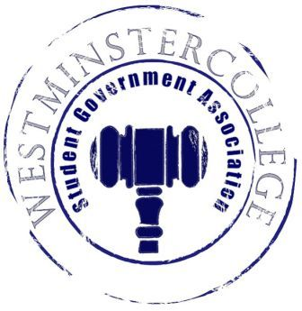
Student Government Association
November 28, 2018
Meeting Minutes

- Prayer by Brandon Williams
- Roll Call and Announcements
All senators are here and accounted for except Caroline Hess.
- Approval of Minutes
- Motion to approve last week’s minutes by Dylan John, seconded by Faith Howell.
- Executive Officers Report
President – Sarah Conn
- No Report
Vice President – Keely Flynn
- No Report
Secretary – Bill Madeja
- There was 32 Senators in attendance tonight.
Treasurer – Matt McDonald
- Expenses for the week:
  - November MO Statements - $136.40
  - Fall Fest Golf Carts -$710
Open Forum
Committee Meetings
Finance – Kyle Kovach
- No Report
Academics – David Peffer
- No committees met the last two weeks
- Academic Concerns:
  - Construction in Hoyt disturbing classes and labs.
- Finals Week Ideas
  - Discussion of De-stressing ideas for Finals Week in the Library
Diversity – Celine Hildack
- Diversity Celebration with Karaoke in Berlin Lounge
- Allies Event
Special Events – Patricia Loughney
- No Report
Service – Mackenzie Basalla
- Friendly reminder that the Clothing Swap is next week, December 7th
  - Please fill out survey for when the best time for the Clothing Swap would be
Student Concerns – Dom Boston
- Discussion of By-law revisions, voting will need to occur in New Business.
- Last meeting for FAC occurred this past week
  - New Meal Plan for Berlin Village Residents to come
  - Duff Updates to come as well
- Public Safety and Physical Plant are doing their best with all the hazardous ice on campus.
- SEC
  - Met and discussed campaigning guidelines and executive council applications.
- Student Concerns:
  - Tub Closed early and caused inconvenience for students with later classes and RA’s that had to stay later on campus.
  - Dom to follow up with Jeff from Sodexo.
  - Discussion of to-go carriers from dining areas
    - Searching for possible ways to reduce wasting the plastic carriers
Public Relations – Kendall Graham
- Discussion of “Meet the Senate”, it will partake tomorrow.
  - Senators to fill out survey
- Christmas Party to Take Place in Witherspoon next week.
- Old Business
- New Business
  - Motion by Tyler Snodgrass to discuss By-Law changes, seconded by Dan Jackson.
  - Motion by Sam Sherlock to vote on By-Law Changes, seconded by Marissa Decker.
    - Majority vote by the Senate, By-Law Changes Approved.
- Open Floor
  - Last CPC Bingo “Grocery Themed” at 7 p.m. in Berlin Lounge, Grand Prize is Amazon Echo Dot.
  - December 7th SPS will host a Physics study session from 6-8 p.m.
  - Theater Westminster performing on December 7th and 8th at 7:00 p.m.
  - Phi Mu is selling pancakes tickets and will receive the pancakes on December 9th
    - $3 tickets from Phi Mu sisters
  - Theta Chi is selling bags of Kettle Corn for $5 that ends tonight.
    - Hoagies and Pepperoni Rolls will be sold till Friday, see a brother for purchasing.
  - Swim Team selling $10 raffle tickets to Steeler Game, Steelers vs. Bengal.
    - Free Parking Pass
    - Seats on the 50 yard line
    - Free $100 for Tailgating as well
  - Limited Seats left for Ice Skating at the PPG Place on Saturday, tickets being sold in the TUB tomorrow!
- Adjournment
- Motion to adjourn by Annalisa Echevarria, seconded by Faith Howell.

