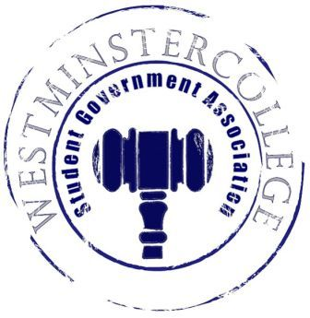
Student Government Association
September 26th, 2018
Meeting Minutes

- Prayer by Brandon Williams
- Roll Call and Announcements
All senators are here and accounted for except Meghan Long, Emilio Rivera, Nikyah Beckwith, and Jasmine Woodings.
- Approval of Minutes
- Motion to approve last week’s minutes by Brandon Williams, seconded by Dylan John.
- Executive Officers Report
President – Sarah Conn
- New Slate information session in November for next year
  - Date is to be determined
Vice President – Keely Flynn
- Thank you everyone for your help during FallFest!!
Secretary – Bill Madeja
- 37 Senators in Attendance tonight
Treasurer – Matt McDonald
- Expenses for the week:
  - Fall Fest T-shirts- $3,930
  - Fall Fest Supplies- $42.51
  - Fall Fest Pizza- $630
  - Fall Fest Apple Castle- $525
- September MO- $83.82
- Student Organizational Cook-Off Reimbursements (thus far)- $231.62
- Homecoming Regalia- $168.97
Open Forum
Committee Meetings
Finance – Kyle Kovach
- No Report
Academics – David Peffer
- Academic concern
  - Students are not able to stay later in Hoyt to finish labs and work
    - Will be more thoroughly investigated
- Mentorship Program Application Deadline extended to One Week from Today
Diversity – Celine Hildack
- No Report
Special Events – Patricia Loughney
- Organizational Cook-Off was a success!
- Discussion of who to select for the Titan Mascot for this Friday’s Alumni Event
- Starting Themes for Home Football Games:
  - White-out for Saturday’s home game against Case Western
  - Everyone Wear White!!
Service – Mackenzie Basalla
- More Chalkboards to be placed around Campus
  - Where? Patterson by the Art Gallery
- Discussion of possibly participating in the New Castle Rescue Mission Food Drive
- Discussion of doing another Clothing Swap sometime in October
Student Concerns – Dom Boston
- Sodexo Survey emailed out, one survey participant will win a $50 gift card!
- Follow up on the Tub salad bar being open on weekends; more information needs to be finalized
- October 10th is when Student Concerns meets with FSAC to discuss food service
  - Open to public to voice any opinions or new options
- Discussion of SEC (Slate Election Committee)
  - More information to be emailed out
Public Relations – Kendall Graham
- New Castle Holiday Parade
  - Discussion of possibly having Organizations participate in the parade
- Old Business
- New Business
- Open Floor
  - CPC presents Steel Blossoms to perform on Friday September 28th in Berlin Lounge!
    - A Former Titan is a part of the band
    - Go out and support a Titan Alumna!!
  - Reminder to fill out Sodexo Survey for a chance to win a $50 gift card!!
    - Survey Feedback assists Sodexo in making changes that benefit students
- Adjournment
- Motion to adjourn by Brandon Williams, seconded by Brice Bokesch.

