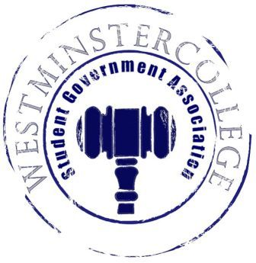
Student Government Association
October 24, 2018
Meeting Minutes

- Prayer by Brandon Williams
- Roll Call and Announcements
All senators are here and accounted for except Aadil Mirza, Julia Minachio, Shaemour Young, and Nikyah Beckwith.
- Approval of Minutes
- Motion to approve last week’s minutes by Noah Pollio, seconded by Leslee Ellis.
- Executive Officers Report
President – Sarah Conn
- Discussion of the Board of Trustees meeting this past week
- Discussion of ideas to bring into New Wilmington, request of Professor Geidner, council member of New Wilmington
- Swearing in of new First-Year Senator
Vice President – Keely Flynn
- No Report
Secretary – Bill Madeja
- 31 Senators in attendance tonight
Treasurer – Matt McDonald
- Expenses for the week:
  - October Miscellaneous- $123.98
  - Finance Meeting- $50.83
  - Library Scavenger Hunt- $23.67
  - Homecoming Flowers- $267.93
Open Forum
- Student with concern presented about new soccer and lacrosse field being built in Eich field.
- Discussion of funding request for Model UN trip to Chicago, to be discussed more in committee report.
Committee Meetings
Finance – Kyle Kovach
- Discussion of supplemental funding for Model UN, will not be voted on tonight.
  - Finance Committee will further discuss the funding, may be voted on a later date.
Academics – David Peffer
- Academic Concerns:
  - Public Safety closing the music department too soon.
  - Discussion of possible Women’s and gender study major.
- Library Scavenger Hunt will be held before Fall Break, stay tuned for the start date!
Diversity – Celine Hildack
- Diversity Dodgeball
  - Tub Sitting for signups held Monday, Wednesday, and Friday during lunch
  - $5 per person, 6 people per team, at least one girl!
  - Prizes for the Winner
  - November 11th in Old 77
Special Events – Patricia Loughney
- Discussion of upcoming PAC tournaments, possibly held here on campus
  - Students will try to attend events if games/meets are close
  - If not within travel distance, will possibly have a watch party for them
- November 10th, Titan Mascot is needed for Alumni event in downtown Pittsburgh, PA
Service – Mackenzie Basalla
- Discussion of Haunted Service event with organizations on campus
- Clothing swap coming up, clothes and small dormitory items are preferred for the swap
Student Concerns – Dom Boston
- SEC met this past week
- Salad bar for weekends and possible new meal plans are a pending process.
Public Relations – Kendall Graham
- No Report
- Old Business
- New Business
- Open Floor
  - Phi Tau is selling Chocolate covered pretzels, 2 pretzels for $2
  - Westminster Ghost Tours on Wednesday October 31st start @ 9:30 p.m.
    - Tour starts in Berlin Lounge
  - Swim team selling shirts during lunch hour the next few days
    - $15 dollars per shirt
  - CPC hosting a DIY event, Autumn Leaf Bowl, tomorrow @ 7:00 p.m.
  - November 3rd, Sigma Kappa Bingo in Berlin Lounge 8-10 p.m.
  - Diversity Dodgeball donations going towards earthquake relief in Haiti
  - Argo senior pics are on November 7th & 8th
  - Sig Eps Balanced Man Scholarship application due November 1st
- Adjournment
- Motion to adjourn by Marissa Decker, seconded by Garrett Garlock.

