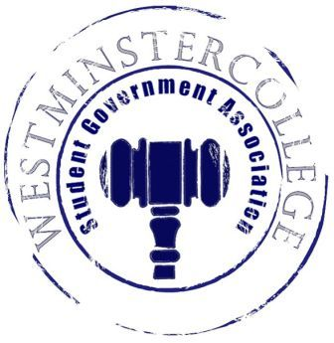
Student Government Association
January 23, 2019
Meeting Minutes

- Prayer by Brandon Williams
- Roll Call and Announcements
All senators are here and accounted for except Caroline Hess, Brett Bartholomew and Mason Flanigan.
- Approval of Minutes
- Motion to approve last week’s minutes by Andrius Burnelis, seconded by Dylan John.
- Executive Officers Report
President – Sarah Conn
- Professor Geidner spoke on the behalf on the New Wilmington Council
  - Inquiring if Westminster students have any interest in attending the council meeting to give their opinions and perspectives for potential upgrades to the borough
  - Voting for representatives will occur in new business
Vice President – Keely Flynn
- NYC Trip details were presented to the senate
Secretary – Bill Madeja
- 32 Senators in attendance tonight
- January Birthdays were presented as well!
Treasurer – Matt McDonald
- NYC Trip Hotel Expense: $11,141.34
Open Forum
Committee Meetings
Finance – Kyle Kovach
- No Report
Academics – David Peffer
- URAC Committee met before the end of the Fall Semester
  - Discussion of items to presented in promotion of URAC day
  - Volunteers needed for URAC day as well
- PBRC met last week
  - Brief discussion of budget activities, nothing disclosed by President Richardson until a meeting with Student Government is held in the near future.
Diversity – Celine Hildack
- No Report
Special Events – Patricia Loughney
- No Report
Service – Mackenzie Basalla
- Clothing Swap donation center to be selected in next meeting
- Feminine product drive next week
Student Concerns – Dom Boston
- FAC meeting to occur next week on Wednesday, January 30th
- No Student Concerns
Public Relations – Kendall Graham
- Meet the Slate promotion to start next week
- Committee Member of the year voting to take place upon conclusion of the meeting
- Old Business
- New Business
  - Motion by Kaylee Brosius to have attendees from the student body at the New Wilmington Borough Council meeting, seconded by Derek Bakewell.
    - Kaylee Brosius, Jackson Gastmeyer, and Noah Pollio were nominated, and will attend meeting
- Open Floor
  - CPC Presents DIY Mason Jar Event tomorrow night at 7 p.m. in Berlin Lounge
  - CPC hosting Yoga event in Berlin Lounge Tuesday at 7:00 p.m.
  - Tickets for the Kevin Hart movie, “Upside” will be available in the TUB Thursday and Friday
  - BSU is having an event every Friday for the month of February for Black History Month
    - February 22nd BSU will host the Ebony Ball, Free Event
  - 24 Hour Theatre on Friday at 8:00 in Beeghly Theater & on Saturday at 8:00 again in Beeghly Theater
- Adjournment
- Motion to adjourn by Andrius Burnelis, seconded by Annalisa Echevarria

