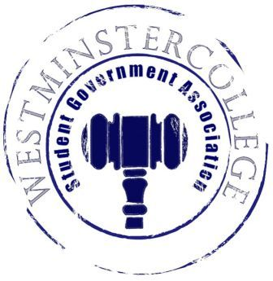
Student Government Association
September 19, 2018
Meeting Minutes

- Prayer by Sarah Conn
- Roll Call and Announcements
All senators are here and accounted for except Jasmine Woodings.
- Approval of Minutes
- Motion to approve last week’s minutes by Dan Jackson, seconded by Ben Kotch.
- Executive Officers Report
President – Sarah Conn
- New Senators were swore in with the Oath of Affirmation
Vice President – Keely Flynn
- FallFest is this Friday September 21st
- Homecoming Court will be announced Saturday, September 22nd during halftime of the football game
Secretary – Bill Madeja
- 34 Senators in attendance tonight
- Review of the attendance policy with the Senators
Treasurer – Matt McDonald
- One expense this week for Fall Fest
  - Tents for Activities- $212.00
Open Forum
- Aadil Mirza speaks on new intramurals league starting up, requesting supplemental funding for this program.
Committee Meetings
Finance – Kyle Kovach
- SAAC allocation Approval
- Intramural Sports requesting Supplemental funding
Academics – David Peffer
- Institutional Review Board, College Appeals Board, and Curriculum Committee all need one more committee member
- Seeking more applicants for the Mentorship Program
Diversity – Celine Hildack
- No report
Special Events – Patricia Loughney
- Organization cook-off is a go!
  - 10 Organizations compete for the best tailgating food!
  - The FREE tailgate is at 12:00pm before the football game
  - Vote on your favorite tailgate food, then watch the Titans take on Bethany College!!
Student Concerns – Dom Boston
- Discussion about student concern of vegan options with accurate labeling of foods
- Request to have the Salad Bar on the weekends in tub
- Amending errors in the Constitution and other possible updates to follow
Public Relations – Kendall Graham
- Senators need to add Kendall on Facebook to see updates on the SGA Senator page
- Promotion of the Fall Fest and Organization Cook-off’s Graphic Designs
  - Share them through the campus!
- “What’s Going on at WC this Week” Post will be making a reappearance, stay tuned!!
- Old Business
  - None
- New Business
  - Motion by Kaylee Brosius to nominate Senators for faculty committees, seconded by Derek Bakewell.
    - Derek Bakewell was only nomination for Curriculum Committee.
      - Congratulations Derek!
    - Andrius Burnelis was only nomination for College Appeals Board.
      - Congratulations Andrius!
    - David Callihan and Garret Garlock were nominated for Institutional Review Board.
    - Motion by Kaylee Brosius to vote on Senators for the Institutional Review Board, seconded by Andruis Burnelis.
      - Congratulations to Garret Garlock!
  - Motion by Kaylee Brosius to vote on allocation for SAAC and supplemental funding for Intramural Sports, seconded by Derek Bakewell.
    - SAAC will receive allocation
    - Intramural Sports will receive supplemental funding
- Open Floor
  - Sigma Phi Epsilon Balanced Man Scholarship opportunity for all Independent Males
    - One $300, two $200, and two $100 dollar scholarships will be offered
  - BSU Meeting at 12:45 tomorrow, September 20th in Berlin Lounge
  - SPS will be having a Pumpkin Launch on Friday September 21st, in Eichenauer field from 4:00pm-6:00pm
  - Zeta Alpha Tau Spooky Social “Let’s Get Spooky” October 19th
    - Tickets are $5
  - CPC Bingo tomorrow, September 20th in the Titan Club from 7-8
- Adjournment
- Motion to adjourn by Kaylee Brosius, seconded by Brett Bartholomew.

