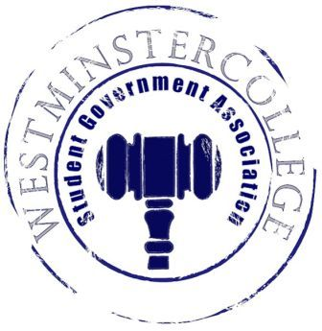
Student Government Association
November 14, 2018
Meeting Minutes

- Prayer by Brandon Williams
- Roll Call and Announcements
All senators are here and accounted for except Brett Bartholomew, Cassidy Nielsen, and Nikyah Beckwith.
- Approval of Minutes
- Motion to approve last week’s minutes by Megan Parker, seconded by Shaemour Young.
- Executive Officers Report
President – Sarah Conn
- Discussion of the SGA survey administered during lunch period in the TUB
  - Further discussion of current results of the survey
  - Discussed how to make the Student Body more aware of SGA and what SGA does
Vice President – Keely Flynn
- No Report
Secretary – Bill Madeja
- There were 36 Senators in attendance tonight
Treasurer – Matt McDonald
- Expenses for the Week:
  - Watch Party Supplies - $127.92
Open Forum
Committee Meetings
Finance – Kyle Kovach
- No Report
Academics – David Peffer
- Curriculum committee met this past week
  - Discussed Capstone guidelines and future improvements
Diversity – Celine Hildack
- Big Thank You to Everyone who helped out with Diversity Dodgeball
- Discussion of Tunnel of Oppression for tomorrow night 6-8 p.m.
- Civil Dialogue this Friday in Lakeview Room at 4 p.m.
- Craft & Sip in Berlin Lounge at 6 p.m. Friday!
- R.E.A.L Conversations about American Politics, Monday at 11:30 a.m. in Berlin Lounge
Special Events – Patricia Loughney
- Possible Student Section for ECAC Bowl Football Game this Saturday
- Discussion of how to improve the Student Section for football games
Service – Mackenzie Basalla
- Thank You to Everyone who came and helped with the Poetry Slam!!
- Clothing Swap will be on December 7th, donation bin is on the third floor of the McKelvey center
- Discussion of Kind Bar Survey
  - When Survey is taken, Kind Bar donates a dollar for each one filled out
Student Concerns – Dom Boston
- Discussion of Inclement Weather conditions
  - Be careful of Icy Sidewalks and Stairs!!
  - If there is an unsalted ice patch on campus, notify Dom Boston ASAP!
Public Relations – Kendall Graham
- Discussion of having the SGA Social Media pages recognized and followed more
- Old Business
- New Business
- Open Floor
  - CPC Bingo Tomorrow Night in Berlin Lounge at 7 p.m.
  - Wind Ensemble performing Friday at 7:30 p.m. in Orr Auditorium
  - Jazz Ensemble performing Sunday at 3 o’clock in Berlin Lounge
  - SPS Movie Night in Planetarium at 7:00 p.m. “The Theory of Everything”
- Adjournment
- Motion to adjourn by Andrius Burnelis, seconded by Annalisa Echevarria

