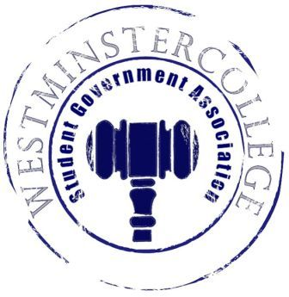
Student Government Association
March 14, 2018
Meeting Minutes

- Prayer by Brandon Williams
- Roll Call and Announcements
All Senators are here and accounted for except Wells Powell
- Approval of Minutes
- Motion to approve last week’s minutes by Adam Himmelman, seconded by Taylor Chock-Wong
- Executive Officers Report
President – Sarah Conn
- Swearing in of new Senators
  - Congratulations to our new senator Cheyenne Shifflett
- President’s SGA Reception Reminder
- Robert’s Rules of Order presentation by Parliamentarian Jackson Gastmeyer
Vice President – Keely Flynn
- VolleyRock committee met this week
  - Theme considerations
  - Giveaway considerations
Secretary – Sam Stewart
- 33 Senators in attendance
  - 89% of total Senate
- Senator of the Month for February is Brett Bartholomew
Treasurer – Matt McDonald
- Weekly Expenses
  - $47.42 for Slate Training Breakfast
Open Forum
Committee Meetings
Finance – Kyle Kovach
- Meeting with Dr. Sarver for Research Professional Advisory Committee (ResPAC) funding
- PowerPoint for organizations explaining Audits and Allocations will be given March 25th
- Audits will be open April 9th through April 30th
- Allocations will be taking place in the fall semester on a date yet to be determined by Student Affairs Associate Dean Gina Vance
Academics – David Peffer
- Committees
  - Have updated contact information for academic committee heads
  - Will be nominating and voting for student representatives during next week’s meeting
Diversity – Celine Hildack
- Thanks to all who came to a successful Fresh Check Day
- Civil Dialogue about gun violence on Friday, March 16th at 4:00pm in Witherspoon
Special Events – Patricia Loughney
- SGA Day planning
  - Newly under control of Special Events
  - New addition- Cash Cart
    - Like Cash Cab game show
    - More details forthcoming
- Homecoming meeting
  - SGA will begin to take on a large portion of Homecoming starting this fall semester
Service – Mackenzie Basalla
- Easter Egg Hunt
  - Wednesday, March 21st
  - Students can find the eggs and bring them to the SGA Office for prizes
- Egg-cellent person compliments
  - Will be TUB-sitting next week
Student Concerns – Dom Boston
- Student Concerns
  - Issues with heating in Ferguson Hall
    - Ongoing work with Physical Plant
Public Relations – Kendall Graham
- Keep checking out the SGA social media accounts
- SGA Senators asked to put signs on their doors to let students know where to go with concerns
- Old Business
  - No Old Business
- New Business
  - Motion by Brett Bartholomew to vote on a theme for VolleyRock 2018, seconded by Taylor Chock-Wong.
    - There will be an American theme for VolleyRock 2018.
  - Motion to open discussion on changing the VolleyRock 2018 giveaway item from sunglasses to visors, seconded by Brett Bartholomew.
  - Motion by Kaylee Brosius, to vote on the giveaway item for VolleyRock 2018, seconded by Ben Kotch.
    - The giveaway item at VolleyRock 2018 will be visors.

- Open Floor
  - Students and Senators with creative abilities are encouraged to send Keely Flynn VolleyRock t-shirt designs with an American Theme
    - flynkc22@wclive.westmisnter.edu
  - Orchestra Concert on Friday at 7:00pm for high school performers to take place in Orr Auditorium
- Adjournment
- Motion to adjourn by Taylor Chock-Wong, seconded by Brandon Williams.

