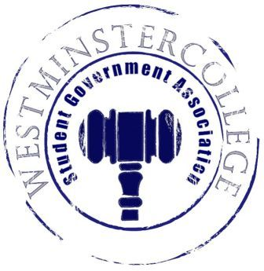
Student Government Association
October 10, 2018
Meeting Minutes

- Prayer by Sarah Conn
- Roll Call and Announcements
All senators are here and accounted for except Derek Bakewell, Jacob Staub, Mason Flanigan, and Jasmine Woodings.
- Approval of Minutes
- Motion to approve last week’s minutes by Kaylee Brosius, seconded by Dan Jackson.
- Executive Officers Report
President – Sarah Conn
- Discussion of issues with Residence Life
  - Slate and Senate reviewed drafted letter containing concerns for Residence Life
  - The Senate gave their input to improve the letter for when it is ready to send
Vice President – Keely Flynn
- Homecoming voting is up on My.Westminster.edu
  - Voting is open until Noon on Friday, October 12th
Secretary – Bill Madeja
- There were 35 Senators in attendance tonight
Treasurer – Matt McDonald
- Expenses for the week:
  - Homecoming Candidate Dinner- $235.68
  - Student Org Cook-Off Reimbursement- $12.90
  - New York City Trip Discussion
    - Allocation of up to $5000 from the Supplemental fund for NYC trip to be approved
Open Forum
Committee Meetings
Finance – Kyle Kovach
- No Report
Academics – David Peffer
- No Report
Diversity – Celine Hildack
- No Report
Special Events – Patricia Loughney
- Homecoming this Saturday!!
  - Pep rally starts at 10:30 in front of McGill Library
  - Bouncy house, food trucks and more!!
  - Student Section for the Football game, wear Westminster gear!
Service – Mackenzie Basalla
- No Report
Student Concerns – Dom Boston
- Discussion of FAC meeting
  - Logistics to be worked out for requests made to Sodexo
  - Another FAC meeting will be held on October 24th
Public Relations – Kendall Graham
- No Report
- Old Business
- New Business
  - Motion by Sam Sherlock to vote on allocation to move up to $5000 of supplementing funding for the NYC trip budget, seconded by Brandon Williams.
    - Funding of up to $5000 approved for the New York City Trip
- Open Floor
  - Student Section for Saturday’s Football game against Thiel College
  - Theater Westminster presents Loves Labors Lost in Beeghly Theater
    - Thursday-Saturday @ 7:30 p.m. and Sunday @ 2:30 p.m.
  - BSU Meeting @ 12:45 tomorrow
  - SPS presents Interstellar for Planetarium Movie night with Popcorn and Pizza @ 6:00 p.m. this Friday
  - Kappa Delta hosting Shamrock Week
    - October 20th Baked Potato Bar 5-8 p.m.
    - Where? Church across the street from Old Main
    - $5 tickets from sisters
  - Zeta Alpha Tau hosting Spooky Social
    - Tickets can be purchased from a sister for $5
  - Emergency Alert System email sent out by J.J. Walker
    - Sign up to receive emergency alerts occurring on campus or in town
- Adjournment
- Motion to adjourn by Sam Sherlock, seconded by Harrison Keenan

