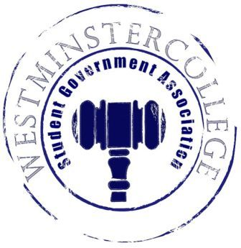
Student Government Association
October 18, 2017
Meeting Minutes

- Prayer by Sarah Conn
- Roll Call and Announcements
All senators are here and accounted for except Jessi Staudacher, Keely Flynn, and Madison Fattman
- Approval of Last Week’s Minutes
- Motion to approve last week’s minutes by Adam Himmelman, seconded by Jacob Staub
- Executive Officers Report
President – Carl Carpenter
- Rollover Ideas
  - Weight clips for the end of the bars
  - Expanding the weight room
Vice President – Anna Daniels
- No Report
Secretary – Rachel Trauner
- There are 34 Senators in attendance
Treasurer – Nataleigh Kerr
- Expenses this Week
  - $954: New York City hotel room deposit
  - $386.14: Reimbursement of shipping Costs for Hurricane Donations
Open Forum
Committee Meetings
Finance – Tyler Sheets
- Allocations Request from Ski Club
  - Their representative will be in next week to present their request
Academics – Austin Arrigo
- Committees
  - No committees met this week
Diversity – Jordan Sherman
- The next Civil Dialogue is scheduled for Tuesday, October 31st at 12:45 – 1:45 in Lakeview
  - The topic has been discussed, and will be announced next week
- The Tunnel of Oppression is coming up; it is on November 2nd from 5:00 - 9:00 PM
  - A representative from each sorority and fraternity will relay the information back to their respective orginizations
    - We would like a wide array of students and groups on campus to be there and to showcase a room
Special Events – Mackenzie Basalla
- Thank you everyone for your help at homecoming!
Service – Elizabeth Smith
- Mohawk High School is collecting shoes, so over fall break be mindful and think about bringing some back to donate!
  - They are collecting until November 25th
- Hurricane Donations have been sent!
  - Money is still coming in through the end of the month
- Staff breakfast is November 21st from 7:00 – 10:00 AM; we will be serving Panera and Dunkin
- HYPA Mentor Program is looking for volunteers; see Liz if you are interested
  - At New Castle High School
  - Partnered with youth in the local area
- Service and SPARK will be partnering in order to start the “Kindness Rocks” on campus
  - Decorating rocks with positivity so that others can find them
  - November 1st
Student Concerns – Tanner Easley
- Student Concerns
  - None
- Please take the time to fill out the Dining Service Survey that went out
- FAC meets tomorrow at 12:30 in Wiesel Conference Room
  - Any food related concerns should be emailed to Tanner
    - Menu systems
    - Food Plan Tiers
    - More gluten free options
      - Be thinking about more options that you would like to see so that Tanner can relate them to Jeff Creveling
- Flies around Sammie’s
- Keep sending Rollover ideas to Tanner
  - If you have something that you want discussed, please make a motion to open up a discussion in New Business
Public Relations – Matt McDonald
- SGA Day is next Friday, October 27th
  - Please sign up for available slots so that we have enough Senators to cover each time slot
  - This will be taking place all day!
  - We will be having Dunkin Munchkins and Apple Castle Donuts
  - Keep posting and sharing Social Media
- Please wear your SGA Quarter zips for SGA Day
  - These will be passed out during next week’s meeting
- Old Business
  - None
- New Business
  - None
- Open Floor
  - Congratulations to Matt and Teddy on Homecoming King and Queen
- Adjournment
- Motion to adjourn by Sarah Conn, seconded by Teddy Constantine

