Westminster College Sports Management

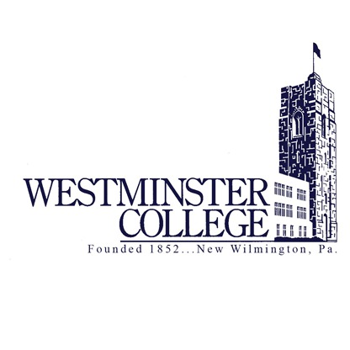

Student Records and Achievements

Vision

We will aspire to be the nation’s premier sports management program at a liberal arts institution, both academically and professionally; a model of excellence for others to emulate, while enhancing the lives of students and preparing them for life beyond graduation.

Mission

To prepare individuals to hone their knowledge in the core areas of communication (including media and public relations), facility and events, finance, law, management and marketing (including sponsorship, licensing and ticketing) through a degree in Sports Management.

Our Amazing Support Team on Campus

Admissions Office: Andria Sloan

Alumni Association: Kara Montgomery, Nicole Hunter, & Linda Wilson

Athletics: Jason Lener, Jim Dafler, Nathan Lariccia, Coach Tammy Swearingen, Sam Divotto & Practicum Sites

Business Office: Gina Carrier, Ruth Curfman, Janet Smith

Campus Security: Osmond Mbaeri & Bonnie Mars

Campus Television, Radio & Newspaper: Gary Swanson, David Barner, Brad Weaver

Career Center: Jen Hough, Bethany Lockie

Dining Services: Jeff Creveling, Mona Moufid

Physical Plant: Jason Janusziewicz

Registrar: Rachel Burns, Colleen Hannon, Scott Wignall

Residence Life: Jeter Smith

School of Business: Linda Travers

Student Life: Francesca Manilla, Linda Thomas, Gina Vance

Off-campus Practicum Sites:
Kennedy Catholic High School, Wilmington High School, Hickory High School
Mahoning Valley Scrappers, Youngstown Phantoms, Y Zone New Castle

MEET OR BEAT

Academic Leaders

Graduated With Honors
Summa cum laude (with highest honor) 3.900
Magna cum laude (with high honor) 3.750
Cum laude (with honor) 3.600

Roth, Ricky ’20 Cum Laude
Hart, Kevin ’19 Magna Cum Laude
Walters, Zachary ’18 Magna Cum Laude

Triple Majors
Howell, Tom ’23 Sports Management, Business Administration,
Marketing & Professional Sales
Horvath, Baylee ’22 Sports Management, Business Administration,
Marketing & Professional Sales
Gregley, Chelsea ’19 Sports Management, Human Resources, Psychology

Graduate Schools
Esposito, Anthony ’22 Westminster College
Highfield, Caden ’22 Virginia Commonwealth University
Jones, Kaitlyn ’21 Xavier University
Iregui, Nick ’21 Westminster College
Granahan, Jack ’21 Nottingham Trent University
Stiemly, Ryan ’20 Valdosta State University
Greene, Tyler ‘20 West Chester University
Spencer, Michael ’19 Alfred University
Barnot, Tyler ’20 Westminster College
Lyczek, Brooke ’20 Defiance College
Pezzuolo, Victoria ’20 Westminster College
Puhalla, Kaelyn, ’20 Westminster College
Gregley, Chelsea ’19 California University of Pennsylvania
Thomas, Melissa ’18 Youngstown State
Walters, Zachary ’18 Westminster College

Graduate Assistantships Earned
Puhalla, Kaelyn ’20 Westminster College Women’s Soccer GA
Esposito, Anthony ’22 Westminster College Sports Information GA
Highfield, Caden ’22 Virginia Commonwealth Univ. UR Ticketing GA
Stiemly, Ryan ’20 Valdosta State University Campus Recreation GA
Spencer, Michael ’19 Alfred University Swimming & Diving GA
Lyczek, Brooke ’20 Defiance College Women’s Basketball GA

Dean’s List
The Dean’s List recognizes students who attain a grade point average of at least 3.6 out of a possible 4.0 with a minimum of 12 course semester hours.

Fall 2022 – 13
Spring 2022 – 14
Fall 2021 – 14
Spring 2021 – 8
Fall 2020 – 13
Spring 2020 – 11
Fall 2019 – 7
Spring 2019 – 4
Fall 2018 – 4
Spring 2018 – 4
Fall 2017 – 4

- Alderette, Aaron – Spring 2022
- Antuono, Frank – Spring 2020
- Barnot, Tyler – Fall 2018, Spring 2019
- Beach, Derek – Fall 2022
- Beck, Emily – Fall 2020, Fall 2021
- Burford, Ethan – Fall 2022
- Byers, Morgan – Fall 2020, Fall 2021, Spring 2022
- Collins, Josh – Fall 2020
- Cora, Kim – Fall 2022
- Dailey, Max – Fall 2022
- Davis, Chris – Fall 2021, Spring 2022, Fall 2022
- Dominguez, Brandon – Spring 2020, Spring 2021, Fall 2021
- Francisco, Gia – Fall 2021, Spring 2022, Fall 2022
- Glaser, Josh – Fall 2021, Spring 2022, Fall 2022
- Granahan, Jack – Fall 2019, Spring 2020, Fall 2020, Spring 2021
- Hart, Kevin – Fall 2016, Spring 2017, Fall 2017, Spring 2018, Fall 2018, Spring 2019, Fall 2019
- Hess, Emily – Fall 2021, Spring 2022, Fall 2022
- Highfield, Caden – Fall 2021
- Horvath, Baylee – Fall 2020, Fall 2021, Spring 2022
- Howell, Thomas – Fall 2019, Spring 2020, Fall 2020, Spring 2021, Fall 2021, Spring 2022, Fall 2022
- Iregui, Nick – Fall 2019, Spring 2020, Fall 2020, Spring 2021
- Jadallah, Jad – Fall 2020, Spring 2021
- Kelly, Collin – Fall 2019, Spring 2020, Fall 2020, Spring 2021
- Krawcyzk, Cooper – Fall 2020
- Lauster, Travis – Fall 2015, Spring 2016, Spring 2019
- Leone, Reese – Fall 2020, Spring 2021, Fall 2021, Spring 2022, Fall 2022
- Lewis, Riley – Fall 2020, Fall 2022
- Linhart, Hunter – Fall 2019, Spring 2020
- Manios, Frankie – Fall 2020, Spring 2022
- Norris, Iresha – Fall 2022
- Reed, Nate – Spring 2020
- Reeder, Ty – Spring 2022
- Ritter, Anthony – Spring 2020, Spring 2022
- Ritter, Dan – Fall 2021
- Spencer, Michael – Spring 2018
- Roth, Ricky – Fall 2017, Spring 2018, Fall 2018, Spring 2019, Fall 2019, Spring 2020
- Salvatore, Tyler – Fall 2021, Spring 2022, Fall 2022
- Saunders, Adam – Fall 2018
- Story, Dillion – Fall 2021, Spring 2022
- Tetirick, Bre – Spring 2020
- Thomas, Melissa – Fall 2017
- Walters, Zach – Fall 2014, Spring 2015, Fall 2015, Spring 2016, Fall 2016, Spring 2017, Fall 2017, Spring 2018
- Zamborsky, Felix – Spring 2021

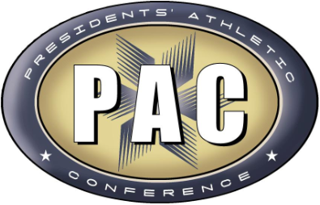
PAC Honor Roll
The Presidents' Athletic Conference Academic Honor Roll recognizes student-athletes on varsity sports teams who have earned a grade-point average (GPA) of 3.60 or higher on a 4.0 scale during their semester of competition.

Fall 2022
Ethan Burford (Football)
Kim Cora (Women’s Soccer)
Gia Francisco (Women’s Tennis)
Josh Glaser (Men’s Soccer)

Spring 2022
Aaron Alderette (Men’s Lacrosse)
Morgan Byers (Women’s Golf)
Chris Davis (Baseball)
Emily Hess (Women’s Basketball)
Baylee Horvath (Women’s Swimming)
Reese Leone (Men’s Basketball)
Frankie Manios (Baseball)
Anthony Ritter (Men’s Basketball)

Fall 2021
Emily Beck (Women’s Soccer)
Brandon Dominguez (Football)
Gia Francisco (Women’s Tennis)
Josh Glaser (Men’s Soccer)
Keenan Heeter (Football)
Tyler Salvatore (Men’s Soccer)

Spring 2021
Emily Beck (Women’s Soccer)
Brandon Dominguez (Football)
Jack Granahan (Men’s Lacrosse)
Nick Iregui (Men’s Soccer)
Jad Jadallah (Men’s Soccer)
Collin Kelly (Men’s Tennis)
Reese Leone (Men’s Basketball)

Spring 2020
Collin Kelly (Men’s Tennis)
Ricky Roth (Men’s Basketball)

Fall 2019
Nick Iregui (Soccer)

Spring 2019
Tyler Barnot (Baseball)
Ricky Roth (Men’s Basketball)

Fall 2018
Adam Saunders (Men’s Soccer)

Spring 2018
Ricky Roth (Men’s Basketball)
Michael Spencer (Swimming & Diving)

Fall 2017
Thomas, Melissa (Women’s Soccer)
Walters, Zach (Men’s Soccer)

Fall 2016
Walters, Zach (Men’s Soccer)

Spring 2016
Lauster, Travis (Baseball)

Fall 2015
Walters, Zach (Men’s Soccer)

Fall 2014
Walters, Zach (Men’s Soccer)

Westminster College Pi Sigma Pi Academic Honor Fraternity
Pi Sigma Pi is a local scholastic honor fraternity whose purpose is to honor superior students. Requirements for membership include a grade point average of at least a 3.6 on the 4.0 scale and the completion of at least 80 semester credit hours. CONTACT:

Howell, Tom – Spring 2022
Lauster, Travis – Fall 2017
Walters, Zachary

Lambda Pi Eta
Lambda Pi Eta is a national honor society in communications. Students need a cumulative 3.0 GPA and a 3.25 GPA or greater in 12 hours of communication classes. CONTACT: Colleen Merrick

Lauster, Travis – Fall 2018

Lambda Sigma
Lambda Sigma is a national sophomore honor society. Members are selected at the end of their first year in recognition of outstanding character, scholarship, leadership and service. A 3.000 GPA is required in addition to previous Westminster College leadership experience. CONTACT: Patricia Clark

Howell, Thomas – Spring 2020
Saunders, Adam – Spring 2019

Mortar Board
Mortar Board is a national honors society for seniors. Members must be in the top 35 percent of their class and its purpose is to promote scholarship, service, and reasonable leadership. Outstanding participation in campus activities is also a requirement. CONTACT: Dr. Zullo

Holzschuh, Camille – Spring 2021 for 2021-2022
Barnot, Tyler – Fall 2018 for 2019-2020
Roth, Ricky – Fall 2018 for 2019-2020
Walters, Zachary – Fall 2017 for 2018-2019

School of Business Honors Banquet
Including scholarship recipients

2023
Horvath, Baylee (Sports Management Student of the Year)
Howell, Tom (Sports Management Student of the Year)
Byers, Morgan (Fuoss Scholarship)

2022
Highfield, Caden (Sports Management Student of the Year)
Byers, Morgan (Fuoss Scholarship)
Leone, Reese (Kendlehart Scholarship)

2021
Antuono, Frank (Sports Management Student of the Year)
Howell, Thomas (Kendlehart Scholarship)
Iregui, Nick (Senior Honors)
Manios, Frankie (Lauterbach Scholarship)

2020
Barnot, Tyler (Sports Management Student of the Year)
Bokesch, Brice (Senior Honors)
Popa, John (Fuoss Scholarship)
Roth, Ricky (Senior Honors)

2019
Spencer, Michael (Sports Management Student of the Year)
Bokesch, Brice (Fishback Scholarship)
Holzschuh, Camille (Kendlehart Scholarship)
Lauster, Travis (Senior Honors)
Long, Dylan (Lauterbach Scholarship
Roth, Ricky (Bill Rankin Award)

2018
Bokesch, Brice (Lauterbach Scholarship)
Hart, Kevin (Kendlehart Scholarship)
Long, Dylan (Kendlehart Scholarship)
Walters, Zach (Senior Honors & Learning Center Volunteer)

2017
Walters, Zach (Lauterbach Scholarship)

Business Plan Competition Scholarship
TBA

Honors Program
TBA

MEET OR BEAT

Campus Leaders

RA’s

Dockum, Jake (Jan. 2022-
Donnelly, Brendan (2021-
Ferrell, Saadiq (2021-2022)
Story, Dillon (2019-2022)
Collins, Josh (2019-
Stamataides, Isaac (2019-2021)
Highfield, Caden (2019-20)
Hart, Kevin (2017-18)

Titan Guides

Brilla, Mike (2021-
Byers, Morgan (2021-
Horvath, Baylee (2019-2022)
Highfield, Caden (2019-2022)
Jadallah, Jad (2019-

Orientation Leaders

Byers, Morgan, (Fall 2022)
Granahan, Jack (Fall 2020)
Howell, Tommy (Fall 2020, Fall 2021, Fall 2022)
Gregley, Chelsea
Swartzentruber, Karen (Fall 2022)

Sportswriters

Francisco, Gia (Spring 2023)
Howell, Tom (Spring 2023)
Francisco, Gia (Fall 2022)
Howell, Tom (Fall 2022)
Salvatore, Ty (Fall 2022)
Zambrosky, Felix (Fall 2022)
Donnelly, Brendan (Spring 2022)
Francisco, Gia (Spring 2022)
Romah, Ben (Spring 2022)
Donnelly, Brendan (Fall 2021)
Highfield, Caden (Fall 2021)
Howell, Tom (Fall 2021)
Romah, Ben (Fall 2021)
Collins, Josh (Spring 2021)
Howell, Tom (Spring 2021)
Jones, Kaitlyn (Spring 2021)
Romah, Ben (Spring 2021)
Collins, Josh (Fall 2020)
Jones, Kaitlyn (Fall 2020)
Esposito, Anthony (Fall 2020)
Zupko, Jordan (Fall 2020)
Biggers, Garvey (Spring 2020)
Esposito, Anthony (Spring 2020)
Esposito, Anthony (Fall 2019)
Story, Dillon (Fall 2019)

Paid Holcad Leadership Positions

Howell, Tom (Fall 2021)
Collins, Josh (Fall 2020, Spring 2021)

Television Practicum

Lewis, Riley (Fall 2021)

Homecoming Court

Baylee Horvath (Fall 2021)
Tom Howell (Fall 2021)

Student Government

Horvath, Baylee
Bokesch, Brice

Study Abroad

Larson, Corrine (Spring 2020)

Alumni Ambassadors

Larson, Corrine (2019-2021)

Team Captains

2022-2023
Reeder, Ty Football

2021-2022
Esposito, Anthony Men’s Tennis
Iregui, Nick Men’s Soccer
Ritter, Anthony Men’s Basketball
Ritter, Dan Men’s Basketball

2020-2021
Granahan, Jack Men’s Lacrosse
Iregui, Nick Men’s Soccer
Ritter, Anthony Men’s Basketball
Ritter, Dan Men’s Basketball
Stamatiades, Isaac Men’s Basketball
Barnot, Tyler Baseball

2019-2020
Antuono, Frank Football
Barnot, Tyler Baseball
Gonzalez, Paul Football
Greene, Tyler Football
Iregui, Nick Men’s Soccer
Lyczek, Brooke Women’s Basketball
Pezzuolo, Victoria Softball
Pierce, Aaron Football
Trella, Nick Men’s Lacrosse

2018-2019
Gonzalez, Paul Football
Greene, Tyler Football
Pierce, Aaron Football
Lauster, Travis Football

2017 & Before
Cooke, Kylie (Women’s Basketball, ’16-’17 & ’17-’18)
Foremski, Kornel (Men’s Tennis, ’16-’17 & ’17-’18)
Thomas, Melissa (Women’s Soccer, ’16 & ‘17)
Walters, Zach (Men’s Soccer, ’16 & ‘17)

MEET OR BEAT

COMMUNITY SERVICE LEARNING DONATIONS

2021-22 American Cancer Society $1,032.81
2021-22 Arise (formerly Crisis Shelter) $51.97
2020-21 Crisis Shelter of Lawrence County $773.30
2019-20 American Cancer Society (thundersticks) $125

Experiential Learning Leaders

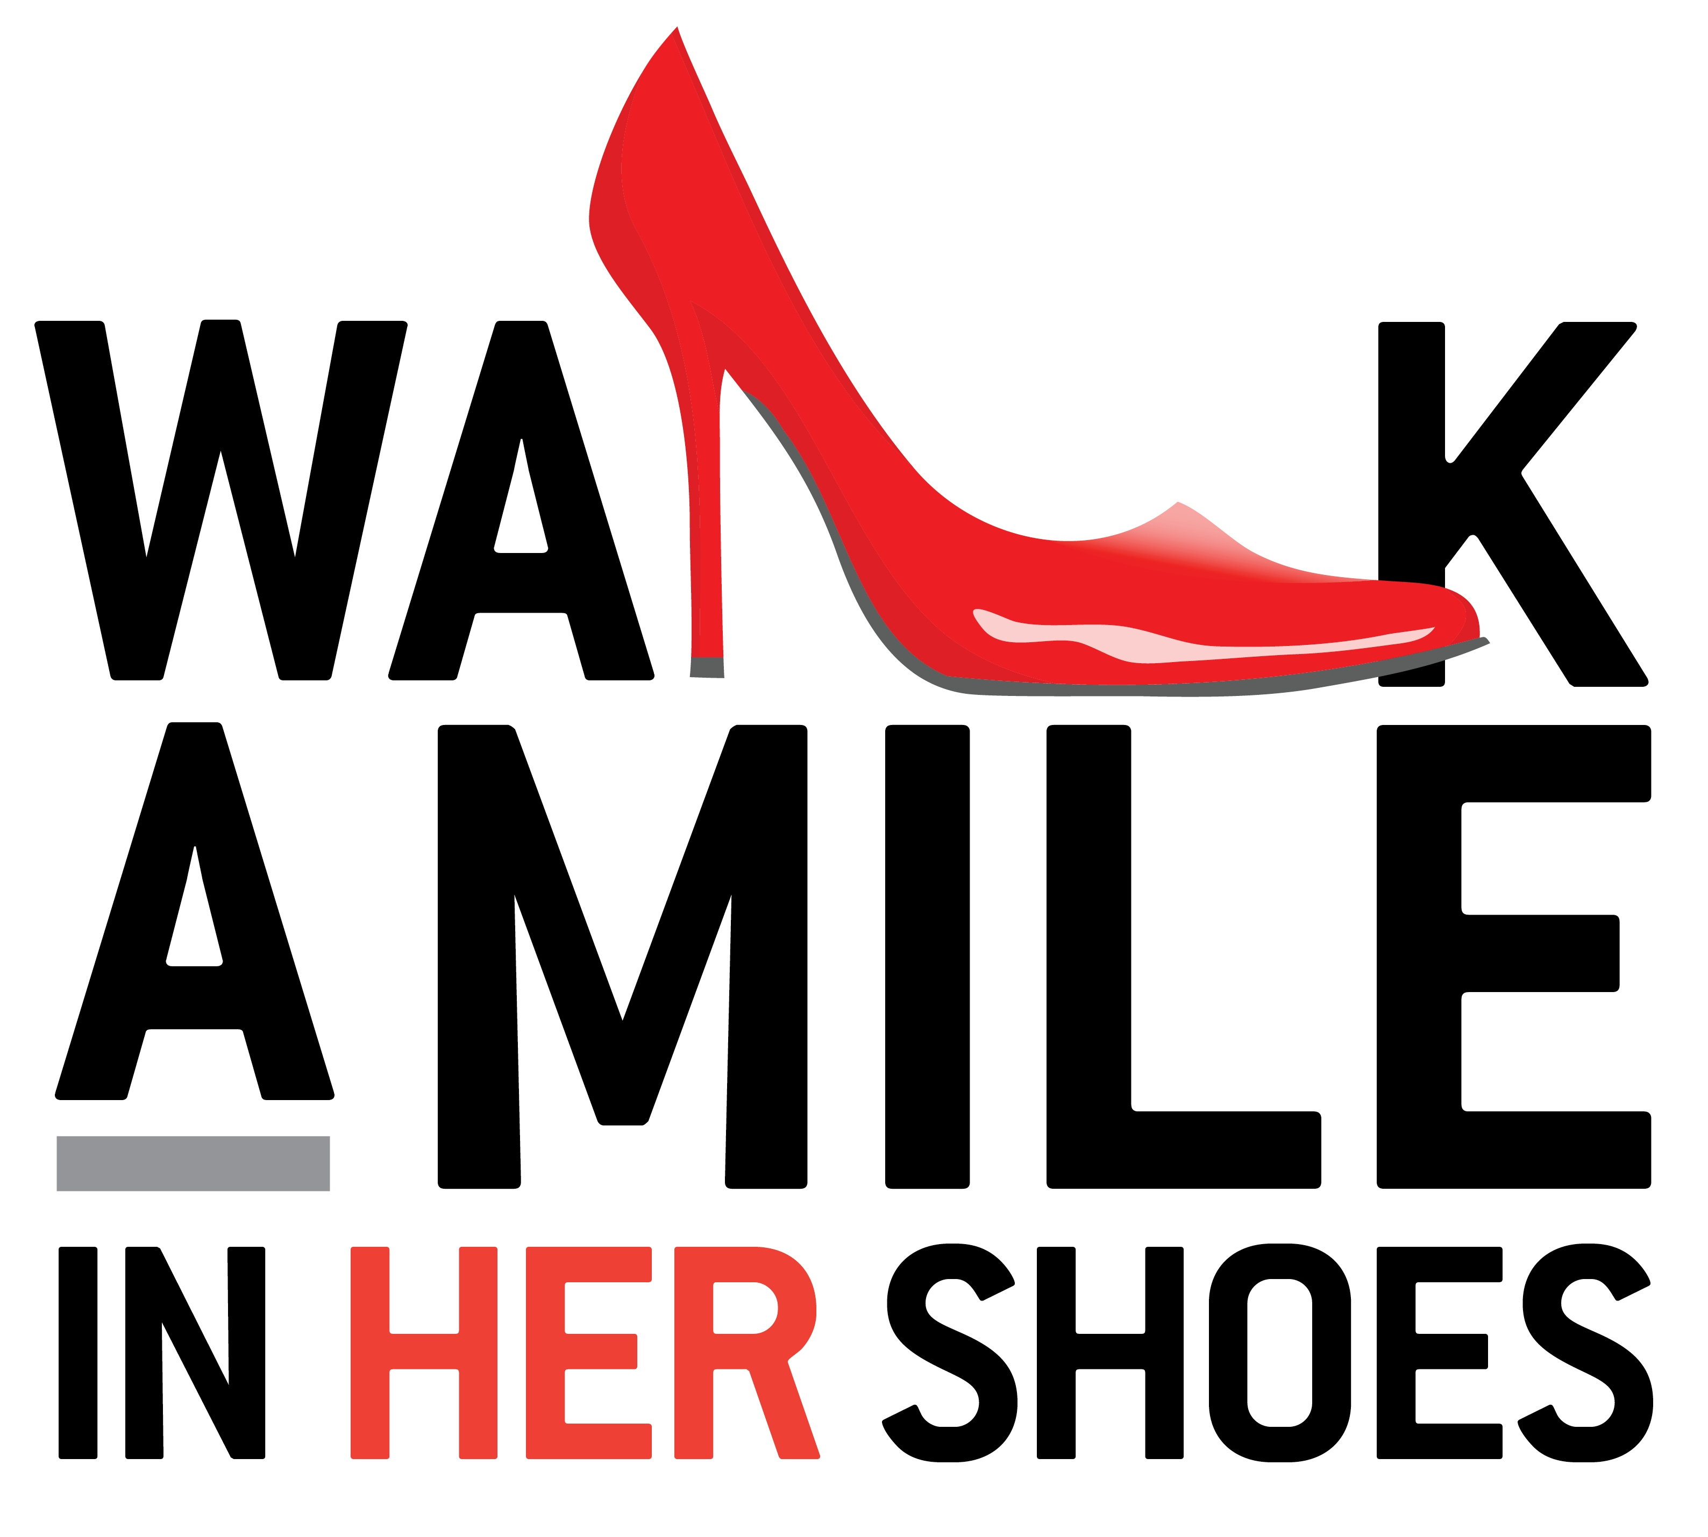

Capstone Walk a Mile in Her Shoes

2021 75 participants, 107 calendars sold by students
2020 Postponed due to Covid
2018 Inaugural event

Enactus Student Organization

- Horvath, Baylee (Spring 2020)
- Dublin, Zach (Spring 2019)
- Hart, Kevin (Spring 2018)

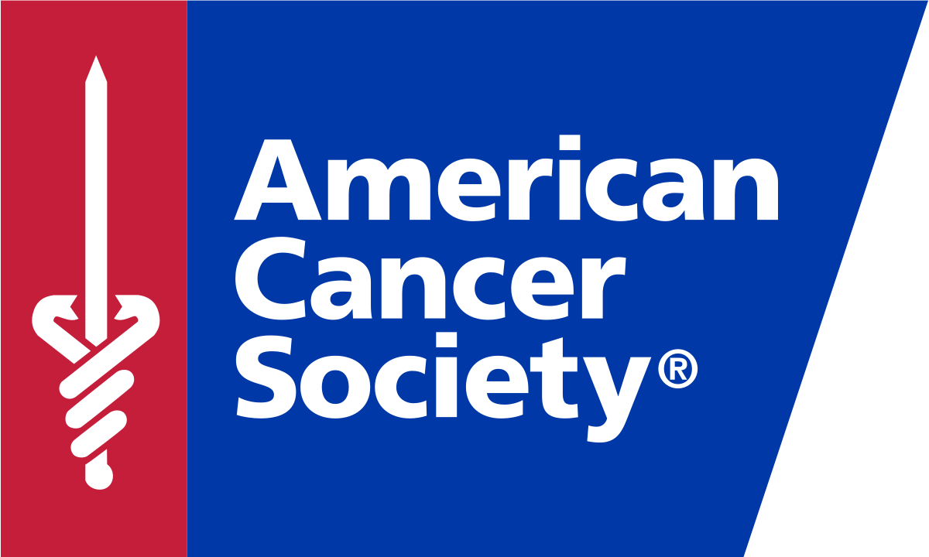

American Cancer Society Thunderstick Sales

- 192 Ahreon Wharton (MBB DH, 2021)
Tavarus Brown (MBB DH, 2021)
Noah Petro (MBB DH, 2021)
- 137.08 Terry Miller (VB, 2021)
Deondre McKeever (VB, 2021)
- 122 Brock Barrett (FB, 2021)
Trey Carter (FB, 2021)
- 94 Karen Swartzentruber (MSOC, 2021)
Chey Lecour (MSOC, 2021)
- 87.50 Tyler Salvatore (WSOC, 2021)
Josh Glaser (WSOC, 2021)
- 79 Shawn Kernaghan (WSOC, 2019)
Sean Fitzpatrick (WSOC, 2019)
- 66 Saadiq Ferrell (VB at PAC, 2019)
Mark Mangino (VB at PAC, 2019)
- 59 China Tate (S&D, 2019)
- 33 Aaron Bell (VB, 2019)
Shamar Love (VB, 2019)
- 22 Aaron Bell (MSOC, 2019)
Sarah Douds (MSOC, 2019)

Class Totals
- $1,032.81 SMGT 110 Fall 2021

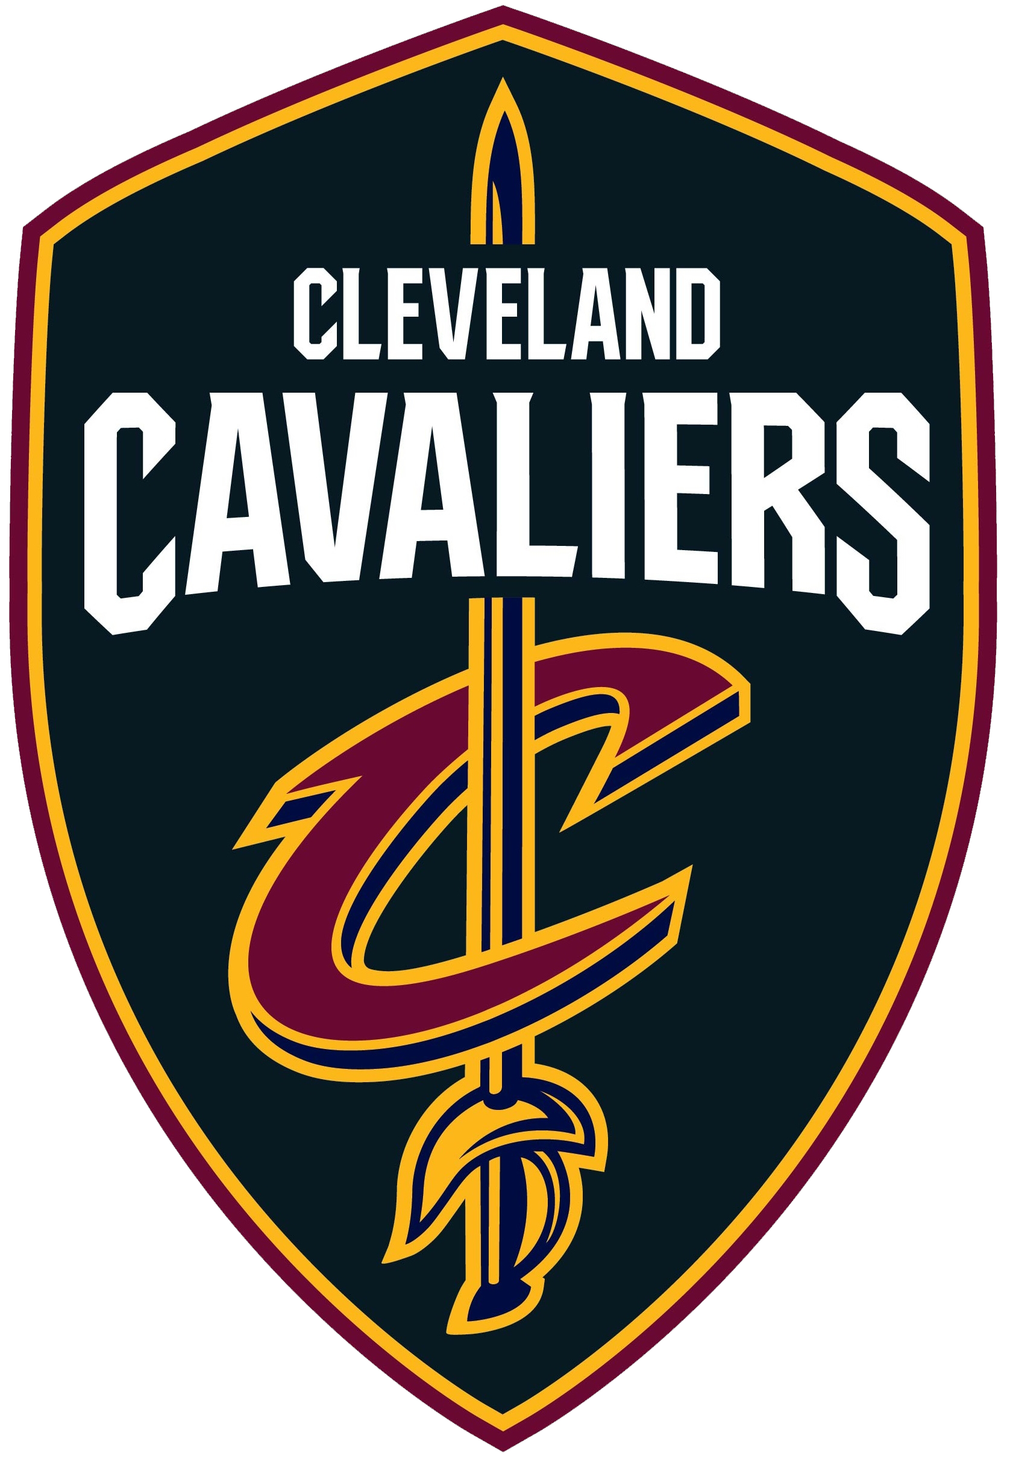

Cleveland Cavaliers Ticket Sales Leaders

- Shamon Walker, 47 (2018)
- Jae Hardy, 41 (2018)
- Nate Taylor, 38 (2022)
- Caden Highfield, 24 (2022)
- Dan Ritter, 22 (2022)
- Nicky Savini, 15 (2018)
- Brandon Dominguez, 14 (2022) and Camille Holzschuh, 14 (2022)
- Baylee Horvath, 13 (2022)
- Tim Spicer, 12 (2022)
- Ty Reeder, 11 (2022), Callie Jacobs, 11 (2018) and Melissa Thomas, 11 (2018)
- Emily Beck, 10 (2022) and Ryan Jolin, 10 (2022)
- Garvey Biggers, 9 (2022)
- Nicole Anderson, 8 (2018) and Mason Grimes, 8 (2018)

Class Averages
BA 335 Spring 2018 = 228/26 or 8.77/student
SMGT 601 Spring 2022 = 186/13 or 14.31/student

Pittsburgh Pirates Ticket Sales:
SMGT 110 Sports Management

- 24 Seth Tatrn (’19)
- 22 Tommy Howell (’19)
- 14 Camille Holtzchuh (’19)
- 12 Katie Henningsen (’19)
- 10 Baylee Horvath (’19) & Jordan Zupko (’19)
Class Averages
SMGT 110 Fall 2019 = 200/32 or 6.25/student

Dr. Zullo’s All-Time Sales Leaders: Seton Hill University:
BU 321 Sports Marketing, BU 470 Sports Leadership & Coaching

- 120 Chris Ilse (SM ’10)
- 73 Jon Gibson (SM ’10)
- 55 Kelsey Criner (SM ’11)
- 53 Anthony Rusch (SM ’12)
- 52 Keith Campbell (SM ’10)
- 47 Nick Erminio* (SM ’11)
- 44 Kevin Gillen (L&C ’16)
- 41 Wendy Scott (SM ’12)
- 41 Josh Forbes (SM ’14)
- 39 Luke Lewis (SM ’16)
- 38 Martina Milcic (SM ’15)
- 36 Brandi Piccolino * (SM ’11)
- 35 Carolin Edenhofner (L&C ’16)
- 35 Cory Kaltenbaugh (SM ’12)
- 35 Jon Deluca (SM ’11)
- 35 Bryan Meteny (SM ’11)
- 35 Joe Tchimou (SM ’12)
- 34 Katie Bloomgren (SM ’12)
- 34 Katie Bloomgren (L&C ‘14)
- 33 Felicia Pawlik (SM ’15)
- 33 Phil Roberts (L&C ‘14)
- 32 Marcus Weakland (L&C ’16)
- 32 Chuck Horsley (SM ’15)
- 32 Phil Roberts (SM ‘13)
- 31 Sam Ritter (SM ’12)
- 30 Anthony Fanelli (SM ’15)
- 30 Trevor Cyr (SM ’14)
- 30 Kevin Gillen (SM ’14)
- 29 Christian Carter (L&C ’16)
- 29 Nick Spino (SM ’11)
- 29 Nick Cozad (SM ’13)
- 28 Brent Daviault (L&C ‘14)

2010 = 34.5/person or 207 sold
2011 = 29/person or 290 sold.
2012 = 38/person or 229 between 6 people
2013 = 13.375/person or 321 between 24
2014 spring = 15.11/person or 287 between 19
2014 fall = 18/person or 270 between 15
2015 spring = 13.6/person or 190 sold between 14
2015 fall = 19.8/person or 377 sold between 19
2016 spring = 17.86/person or 250 sold between 14
2016 fall = 12.91/person or 142 sold between 11
2017 spring = 9.125/person or 146 sold between 16

career readiness Leaders

National Recognition

2022-23 Alliance for Sport Business Case Study Competition – First (1st) Place – Kim Cora, Gia Francisco, Tom Howell

2021-22 National Collegiate Sport Sales Competition – eight participants
Frank Antuono, Brock Barrett, Mike Bell, Brandon Dominguez, Anthony Esposito, Caden Highfield, Tim Spicer, Nate Taylor

2021 National Collegiate Sports Sales Competition – 6th place – Tyler Barnot, Bre Tetirick

2020 Pitt Business Analytics Case Study Competition – National Finalists
Michael Brilla, Tommy Howell, Frankie Manios (postponed due to Covid)

State Recognition

2023 Pennsylvania Sports Business Conference Best Research Award – Riley Lewis

2022 Pennsylvania Sports Business Conference Community Service Award – Baylee Horvath

2020 Pennsylvania Sports Business Conference Most Outstanding Student – Ricky Roth

2020 Pennsylvania Sports Business Conference Community Service Award – Tyler Barnot

2019 Pennsylvania Sports Business Conference Best Research Award – Chelsea Gregley

Conference Attendees

Robert Morris University Sports Management Conference

2022 Derek Beach
2022 Mike Brilla
2022 Kim Cora
2022 Phil Keller
2022 Deondre McKeever
2022 Ty Reeder
2022 Noah Yates
2021 Postponed
2020 Aaron Alderette
2020 Garvey Biggers
2020 Morgan Byers
2020 Connor Chirdon
2020 Stephanie Cimini
2020 Josh Collins
2020 Jake Dockum
2020 Saadiq Ferrell
2020 Katie Henningsen
2020 Eirka Hoover
2020 Ethan Huey
2020 Jad Jadallah
2020 Reese Leone
2020 Riley Lewis
2020 Hugh Livingstone
2020 Lizzy Malczak
2020 Devin Neal
2020 Ty Reeder
2020 Deon Thomas
2020 Felix Zamborsky
2020 Jordan Zupko
2019 NA
2018 Ricky Roth
2018 Michael Spencer
2017 Ashley Chorney
2017 Kevin Cusick
2017 Michael Spencer

Michigan Sport Business Conference

2022 Gia Francisco
2022 Tom Howell
2021 NA
2020 Josh Collins
2020 Reese Leone
2020 Jordan Zupko
2019 NA
2018 Tyler Barnot
2018 Ashley Chorney
2018 Zach Dublin
2018 Jack Granahan
2018 Kevin Hart
2018 Corrine Larson
2018 Romano Veneziano

Wharton Sports Business Summit at Penn
2020 Erika Hoover

Central Michigan Sports Business Conference

2020 Morgan Byers
2020 Stephanie Cimini
2020 Josh Collins
2020 Jake Dockum
2020 Saadiq Ferrell
2020 Dakota Hill
2020 Ethan Huey
2020 Deon Thomas

Mount Union Sports Sales Workshop

2021 TBA
2020 Tyler Barnot
2020 Lloyd Chatman
2020 Preston Stitt
2019 Travis Lauster
2019 Michael Spencer
2018 Kornel Foremski
2018 Raymond Shalvoy

Applied Sport Management Conference
2021 Riley Lewis – two presentations

Penn State University Sports Business Conference

2023 Pat Benedict
2023 Sam Rogers
2023 Alex Shaughnessy
2023 Terry Miller
2023 Nate Bortnick
2023 Iresha Norris
2023 Reese Schneider
2023 Karen Swartzentruber
2021 Frank Antuono
2021 Jack Granahan
2021 Nick Iregui
2021 Collin Kelly
2021 Anthony Rittter
2021 Ben Romah
2021 Isaac Stamatiades
2021 Bre Tetirick
2021 Ian Valente
2021 Romano Veneziano
2020 Postponed by Covid
2020 Frank Antuono
2020 Tyler Greene
2020 Kaitlyn Jones
2020 Brooke Lyczek
2020 Anthony Ritter
2020 Dan Ritter
2020 Ricky Roth
2020 Isaac Stamatiades
2019 Brandon Dominguez
2019 Paul Gonzalez
2019 Camille Holzschuh
2019 Nick Iregui
2019 Kaitlyn Jones
2019 Victoria Pezzuolo
2018 Emily Irvine
2018 Travis Lauster
2018 Melissa Thomas

Pennsylvania Sports Business Conference

2023 Josh Glaser
2023 John Menefee
2023 Tyler Salvatore
2023 Riley Lewis
2022 Mike Brilla
2022 Gia Francisco
2022 Riley Lewis
2022 Karen Swartzentruber
2021 Virtual
2020 Cancelled by Covid
2019 Lloyd Chatman
2019 Chelsea Gregley
2019 Kevin Hart
2019 Nate Reed
2019 Ricky Roth
2018 Zach Dublin
2018 Brett Henderson
2018 Travis Lauster
2018 Kevin Hart

Professional Organizations

WISE – Women in Sports & Events
Morgan Byers (August 2020)
Baylee Horvath (August 2020)
Riley Lewis (August 2020)

AWSM – Association for Women in Sports Media
Kaitlyn Jones (December 2020)
Camille Holzchuh (December 2020)

NACMA – National Association of Collegiate Marketing Administrators
Melissa Thomas (January 2018)

NSCAA – National Soccer Coaches Association of American
Zachary Walters (January 2018)

WBCA – Women’s Basketball Coaches Association
Kylie Cook (January 2018)

Professional Development Center Summer Internship Grants

2019 Ricky Roth

Summer Research Fellow at Westminster College

2020 Antuono, Frank – Division III Corporate Sponsorship

Drinko Center for Undergraduate Research Grants

Josh Glaser, John Menefee, Tyler Salvatore – Spring 2023
Case study competition – PA Sports Business Conference

Kim Cora, Gia Francisco, Tom Howell – Spring 2023
Case study competition – Alliance for Sport Business

Riley Lewis – Spring 2023
Challenges of Women Working in Football Operations and Recruiting at
Power Five (FBS) Schools. College Sport Research Institute

Riley also had similar presentations at the 2023 ASB Conference and
2023 PA Sports Business Conference.

Mike Brilla, Gia Francisco, Karen Swartzentruber – Spring 2022
Case study competition – PA Sports Business Conference

Riley Lewis – Spring 2022
Marketing Strategies in Division III Intercollegiate Athletics: A Case Study
of a Pennsylvania Liberal Arts Institution - PA Sports Business Conference

Riley Lewis – Spring 2021
Industry Interviews, Steve Keener, Little League World Series
Industry Interviews, Maura Murphy, Ohio State Athletic Department
Applied Sports Management Conference

Ricky Roth & Kevin Hart – Spring 2019
Beyond Sports - Impacting the Community: Break Out the Red Heels –
Sports Management Students Plan and Implement a Community Walk
Against Domestic Violence and Sexual Assault – PA Sports Business
Conference

Lloyd Chatman & Nate Reed – Spring 2019
Beyond Sports - Impacting the Community: Strengthening the Division III
Student-Athlete Community Through Career Center Best Practices – PA
Sports Business Conference

Brett Henderson & Zach Dublin – Spring 2018
Conquering the Challenges of Our Future – Declining Intramural
Participation – PA Sports Business Conference

Travis Lauster & Kevin Hart – Spring 2018
Conquering the Challenges of Our Future – A Content Analysis of Division
II Athletic Department Websites in Pennsylvania – PA Sports Business
Conference

