Transact Integrated Payments summary

**VIEWING THE BILL**

Student account statements (bills) are available through Transact Integrated Payments:

STUDENTS: In order to view your bill, follow these steps on *my.westminster*:

Go to *https://my.westminster.edu/ics.*

Log in using your my.westminster login name and password.

Select the Finances tab.

Click on “Go to Transact Integrated Payments.”

Once on Transact Integrated Payments, to view the bill, click on “Statements,” then click “View.”

The Current Balance field is a real-time balance. If you make a payment, it will update the Current Balance. However, the transaction will not appear on a bill until the next time bills are published. If the transaction results in a zero balance, you will not receive an updated bill. Please note that if you are enrolled in a payment plan, the remaining balance on your plan is also reflected in the current balance field.

**ADDING A PERSON TO VIEW YOUR BILL AND/OR MAKE PAYMENTS**

In order for anyone other than the student to view the bill (or make payments), the student is required to set up a Payer within Transact Integrated Payments by completing the following steps on the Transact Integrated Payments website. This is also needed if someone other than the student is setting up and/or paying a payment plan.

Under “Summary,” click “Send a Payer Invitation.”

Enter the person’s first name, last name, and email address.

Select “Yes” to allow access to statements.

Select “Send Invitation.”

They will receive an email from Transact Integrated Payments with instructions on how to login.

The site is *https://commerce.cashnet.com/westminpapay.*

Once logged in, to view the bill click on “Statements,” then click “view.”

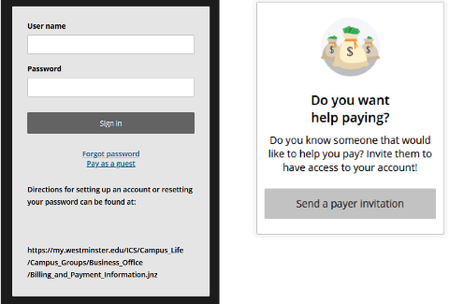

**making Online Payments**

Credit card or e-check and some 529 plans are also accepted as a method of payment.

Transact Integrated Payments charges a convenience fee for credit card transactions (this includes debit cards).

Credit cards accepted: Visa, Mastercard, Discover, American Express and Diner’s Club.

There is no fee for e-check (ACH) payments.

529 payments incur a small fee.

TO MAKE AN ONLINE PAYMENT:

Login to Transact Integrated Payments.

Click on “Make a Payment.”

Select the appropriate item for which you would like to pay by clicking “View Details.”

Then continue on to the next screen:

Enter Amount and any other applicable information requested.

Click button “Add to Payment”

Choose “Continue Payment.”

Once ready to check out, choose whether to you want to pay via Credit Card (includes Debit Card) OR via Bank Account.

Follow the prompts to enter the appropriate account information related to your method of payment.

Complete checkout.

If you would like to pay with a debit card, you must select the credit card option and pay the associated fee. The bank account option requires entry of your bank’s ABA routing number and your checking or savings account number.

Upon completion of the payment, a receipt will be sent to the student’s Westminster email and/or to an alternate email of your choice. If the payment is being made via an additional person payer, then the email associated with the payer’s account will receive the receipt.

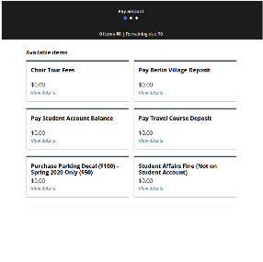

How to Enroll in a Payment Plan:

Step 1: Logging In

**Student Login**

Login to your my.westminster account

Click on “Finances” tab

Click on “Go to Transact Integrated Payments”

Choose “Payment Plans”



**Payer Login (After Payer Account is Created by Student):**

Go to https://commerce.cashnet.com/westminpapay

Choose “Payment Plans”

Step 2: Select a Tuition Payment Plan and Make Your First Payment

Choose a plan from those listed below:

07/01 5,4,3 Pay Fall Plan (fall only)

01/01 5,4 Pay Spring Plan (spring only)

Enter the dollar amount and follow through the various prompts.



If you are having difficulty creating a plan, please contact the Business Office at 724-946-7140 or Transact Integrated Payments at 1-877-821-0625 for assistance.

Step 3: Make timely monthly payments

Payers are required to make the first payment when enrolling in the plan. For subsequent months, login to Transact Integrated Payments and make the payment as follows:

Click on “Make a Payment”

Click on the Payment Plan

Enter “Amount” (should equal the next payment due plus any applicable late fees)

*Your initial payment will include a small enrollment fee

Choose “Add to Payment”

Click “Continue”

Follow the prompts to enter payment information

Payments under the plan will be reflected as reductions to the student account balance each month.

Payment plan adjustments can be made at any time by logging in to Transact Integrated Payments, clicking on the plan, entering a new budget amount, and agreeing to the new payment plan terms and Truth in Lending disclosures.

*If you would like to enroll in automatic payment withdraws you must do this as a separate step.

CREDIT BALANCE REFUND THROUGH ELECTRONIC DEPOSIT - SIGN UP

• Sign up as follows:

Go to *https://my.westminster.edu/ics.*

Log in using your my.westminster login name and password.

Select Finances tab.

Click on “Go to Transact Integrated Payments.”

Click on “Sign Up for Direct Deposit Refunds.”

Follow instructions to add bank account information for the refund.

*\*If you opt in for e-refund, this is the default method for which you will receive your refund*

*unless you withdraw from e-refund.*

The student must come to the Business Office during normal operating hours to sign a refund request. The Business Office will notify a student when the refund has been processed.

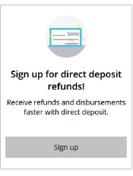

Transact Integrated Payments - Past due accounts that have username (previously PIN)

1. Go to commerce.cashnet.com/westminpapay
2. Enter your user name
3. Pay as guest
4. Enter your Westminster ID and Last Name
5. Choose pay student account balance
6. Proceed through the steps to choose payment method, enter dollar amount, and submit payment

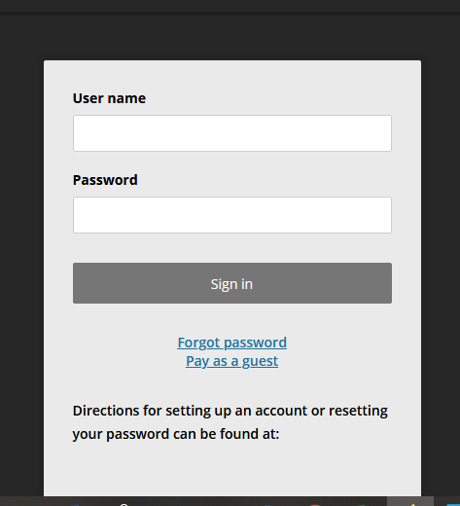

Transact Integrated Payments – reset PAYER password

The student must initiate the password.

1. Login to Transact Integrated Payments
2. Click My Account
3. Click the Payer you would like to reset the password for
4. Click resend payer invitation